Metal Braces
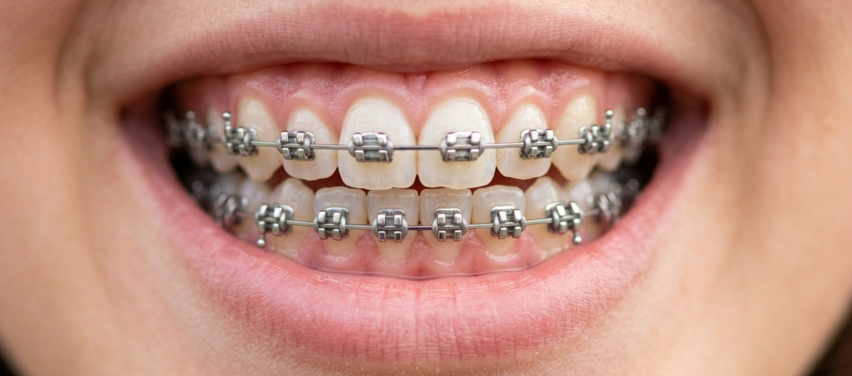
Metal Braces: Trusted, Powerful, and Proven
Get a confident, well-aligned smile with metal braces—the most reliable option for correcting crowding, spacing, and a wide range of bite issues from childhood through adulthood.
Why metal?
- Powerful: handles complex cases and heavy mechanics better than other braces
- Effective: consistent, predictable results for mild to severe issues
- Affordable: typically the most cost-effective orthodontic option
- Durable: strong stainless steel brackets resist breakage
Quick care tips
- Brush after every meal; use interdental brushes or floss threaders
- Avoid hard/sticky foods (nuts, ice, caramel, hard candies)
- Limit stain triggers if you have elastic ties; rinse and brush after coffee, tea, curry
- Use orthodontic wax for poking wires; call us for loose/broken brackets
- Soreness after adjustments? OTC analgesics + warm salt rinses help
Treatment at a glance
- One-day bonding after consult + digital scan/X-rays
- Adjustments every 4–8 weeks
- Typical treatment: 12–36 months (complex cases may take longer)
- Finished with retainers to keep your smile stable
Book your consultation today and start your journey to a stronger, healthier, more confident smile.

.
Ceramic Braces
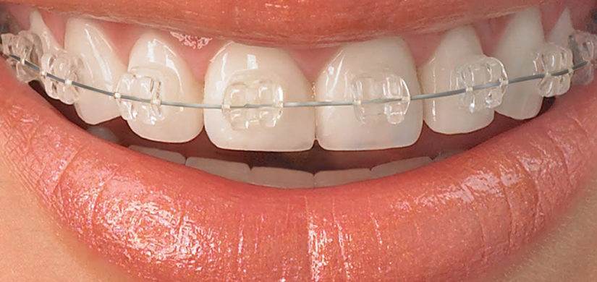
Ceramic Braces: Nearly Invisible, Fully Effective
Transform your smile with ceramic braces—tooth-colored brackets that blend naturally while delivering precise alignment for crowding, spacing, and mild bite issues. Perfect for teens and adults who want reliable results without the metal look.
Why ceramic?
- Discreet: tooth-colored brackets = far less noticeable than metal
- Effective: proven movement for mild–moderate cases
- Comfortable: smooth surfaces reduce irritation
- Confidence: the cosmetic choice many patients prefer
Care in a flash
- Brush after every meal; use interdental brushes or floss threaders
- Avoid hard/sticky foods (nuts, ice, caramel)
- Limit stain triggers (coffee, tea, red wine, curry); rinse and brush after
- Use orthodontic wax for poking wires; call us for loose/broken brackets
Treatment at a glance
- One-day bonding after a quick consult + digital scan
- Adjustments every 4–8 weeks
- Typical treatment: 12–36 months
- Finished with retainers to keep your smile stable
Book your consultation today and smile with confidence—subtly.

Self-Ligating Braces
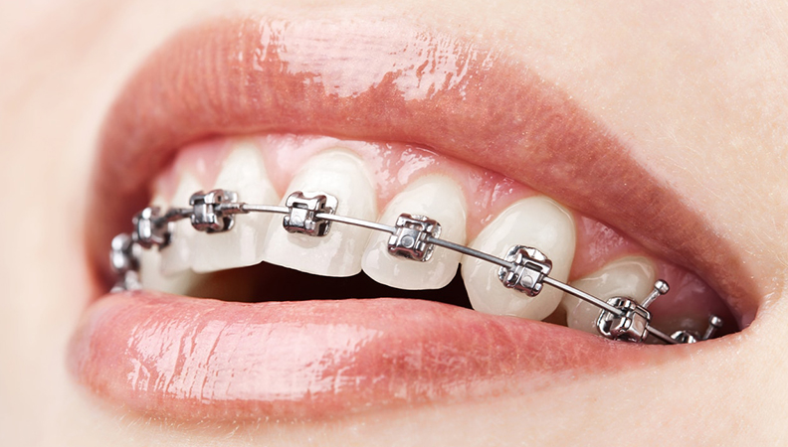
Self-Ligating Braces: Faster, Cleaner, More Comfortable
Upgrade your smile with self-ligating braces—brackets that use a built-in metal clip instead of elastic ties. They deliver lower friction for smoother tooth movement, make hygiene easier, and often feel more comfortable after adjustments. Many patients enjoy longer intervals between visits and fewer plaque traps than conventional braces. Ideal for mild to moderate crowding, spacing, and bite correction in teens and adults. Starts with a quick consult and scan, then bonded in one visit; adjustments every 4–8 weeks (sometimes 6–10), and you’ll finish with a polished bite and a retainer plan to keep results stable. Clean after every meal, skip hard/sticky foods, and use wax for any poking wires. Book your free consultation today and see how a smarter brace design can give you a confident smile with less fuss.

.
Lingual Braces
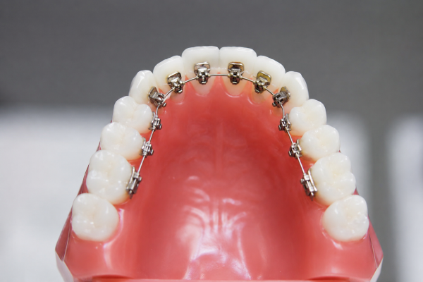
Lingual Braces: Invisible From the Front, Powerful Inside
Transform your smile with lingual braces—brackets placed on the back (tongue side) of your teeth so they're completely hidden from view. Ideal for teens and adults who want noticeable results without anyone seeing their braces.
Why lingual?
- 100% invisible: no front-facing brackets or wires
- Effective: handles crowding, spacing, and many bite issues
- Professional confidence: perfect for public-facing roles
- Comfortable once adapted: smooth surfaces reduce lip irritation
Quick care tips
- Brush after every meal; focus on the tongue-side brackets with interdental brushes
- Avoid hard/sticky foods (nuts, ice, caramel) that can loosen brackets
- Initial speech adjustment is normal; practice speaking and reading aloud
- Use orthodontic wax for any poking wires; call us for loose brackets
- Soreness after adjustments? OTC analgesics + warm salt rinses help
Treatment at a glance
- Specialized consult + digital scan to plan precise back-of-teeth placement
- Bonding takes slightly longer due to access difficulty
- Adjustments every 6–8 weeks (specialist follow-up)
- Typical treatment: 18–36 months depending on complexity
- Finished with retainers to lock in your invisible smile
Note: Lingual braces require an experienced specialist and may not suit very severe cases or patients with certain tongue-thrust patterns.
Book your consultation today and smile confidently—completely invisible.

Clear Aligners
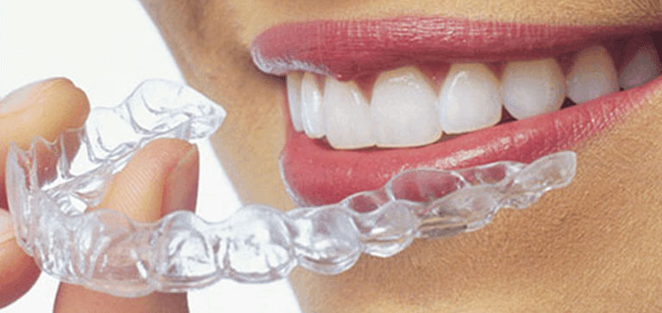
Clear Aligners + Invisalign: Invisible, Removable, and Trusted
Straighten your smile with clear aligners—and experience the leading brand, Invisalign. These custom, transparent trays gently shift teeth into place and are nearly invisible when worn. Invisalign is the most researched and widely used clear aligner system, backed by millions of treatments and advanced software (SmartTrack material and SmartForce attachments) for precise, comfortable results.
Why choose Invisalign clear aligners?
- Invisible: nearly undetectable so you can smile confidently during treatment
- Removable: eat freely and maintain easy brushing/flossing
- Comfortable: smooth medical-grade plastic (SmartTrack) reduces irritation
- Precise: ClinCheck 3D planning lets you see your projected outcome before starting
- Convenient: fewer office visits; many progress checks are remote
Quick care tips
- Wear 20–22 hours/day; remove only to eat, drink (except water), and brush
- Brush and floss before reinserting; clean aligners daily with a soft brush and clear soap or Invisalign cleaner (no hot water)
- Store in your case when not worn; avoid colored/hot drinks while wearing
- Mild pressure or soreness when starting a new tray is normal
Treatment at a glance
- Digital scan to create your custom ClinCheck plan
- Receive a series of trays; change every 1–2 weeks as directed
- Typical treatment: 6–18 months for mild to moderate cases (complex cases may take longer)
- Progress checks every 8–12 weeks (in-office or remote)
- Finished with Invisalign retainers to maintain your new smile
Best for: mild crowding/spacing, minor bite adjustments, and adults/teens seeking a cosmetic, low-maintenance option. Severe skeletal or complex orthodontic problems may require braces or a combined approach.
Book your Invisalign consultation today and get a straighter smile—clear, simple, and barely seen.

Palatal Expanders
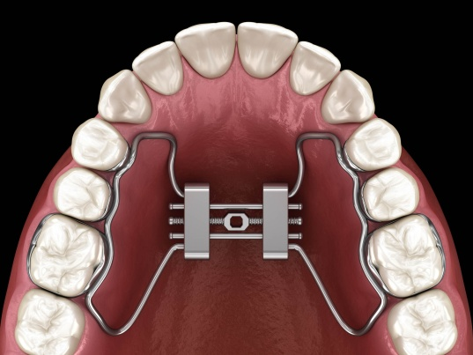
Palatal Expanders: Wider Airway, Better Bite, Confident Smile
Broaden your upper jaw with a palatal expander—perfect for correcting a narrow arch, crowding, crossbite, and even supporting better breathing. Great for kids and teens, and now effective for adults too with MARPE (Miniscrew-Assisted Rapid Palatal Expansion).
Why expand?
- Fixes crossbite and narrow arches
- Creates space for crowded teeth (often avoiding extractions)
- Improves airflow and can support better breathing
- Sets the foundation for a balanced, stable bite
Kids & teens (traditional expanders)
- Works with natural growth for quick, comfortable results
- Typically used before or during orthodontic treatment

Adults (MARPE)
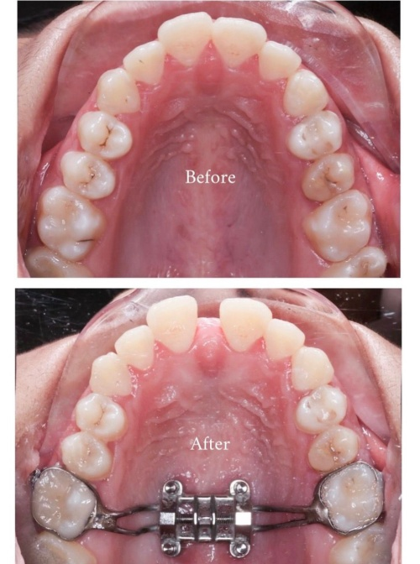
- Growth is complete—MARPE uses small miniscrews anchored to the bone for precise, skeletal expansion
- More predictable bone expansion than tooth-only methods in adults
- Often done before braces/aligners to optimize arch width and bite
Quick care tips
- Follow your activation schedule exactly (turn key as directed)
- Keep up with brushing; use a small brush or water flosser around the expander
- Avoid hard/sticky foods (nuts, ice, caramel) that can bend or break the device
- Mild pressure or a gap between front teeth is normal during expansion
- Use orthodontic wax if there's irritation; call us for loose screws or broken parts
Treatment at a glance
- Consultation + 3D scan/X-ray to plan expansion
- Custom expander fitted and activated at home (or in-office for certain types)
- Expansion phase: typically 2–4 weeks of daily turns
- Retention: device stays in place for several months to let bone stabilize
- Next steps: braces or clear aligners to fine-tune alignment (if needed)
Expected outcomes
- Wider arch, improved bite, and often better airflow
- More room for teeth, reducing crowding
- Stable results with proper retention and follow-up
Follow-up
- Regular checks every 4–6 weeks during activation and retention
- Post-expansion imaging to confirm skeletal change (especially for MARPE)
- Long-term retention plan to maintain width and bite
Book your consultation today and discover how a wider arch can transform your bite, breathing, and smile—with pediatric expanders and adult MARPE options.

Twin Block Appliance
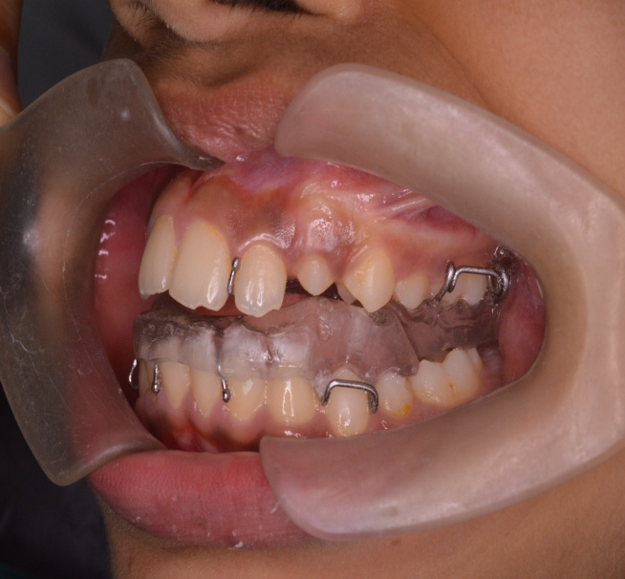

Twin Block Appliance: Correct Your Overjet, Grow Into a Better Bite
Fix a retruded lower jaw and improve your Class II overjet with the Twin Block Appliance—a functional orthodontic device that encourages the lower jaw to grow forward while aligning teeth. Ideal for growing children and teens who need jaw correction before braces.
Why Twin Block?
- Corrects Class II overjet (retruded lower jaw) efficiently
- encourages natural lower jaw growth during development
- Two-piece design (upper + lower blocks) allows comfortable chewing and speech
- Often reduces the need for later jaw surgery or prolonged braces
- Can be used alongside or before fixed braces for optimal results
Limitations
- Works best in growing patients (children/teens); limited skeletal effect in adults
- Requires strong compliance: must be worn full-time as directed
- Initial speech/eating adjustment is common
- Not suitable for all bite patterns (e.g., certain open bites or severe skeletal issues)
Treatment at a glance
- Consultation + scans/X-rays to confirm Class II and growth status
- Custom Twin Block fabricated and fitted
- Activation: wear full-time (typically 22+ hours/day) for 6–12 months
- Follow-up: progress checks every 4–6 weeks
- Next phase: braces or clear aligners to finalize alignment after jaw correction
Patient instructions & care
- Wear full-time as prescribed; remove only for eating and cleaning
- Practice speaking and chewing; mild discomfort is normal initially
- Clean blocks daily with a soft brush and cool water (no hot water)
- Avoid hard/sticky foods that can bend or break the appliance
- Store in your case when not worn; bring to every appointment
- Use orthodontic wax for irritation; call us for loose parts or broken blocks
Expected outcomes
- Reduced overjet and improved bite relationship
- Better jaw positioning and smile aesthetics
- More stable results when completed during active growth
- Often shortens overall braces time later
Follow-up recommendations
- Regular checks every 4–6 weeks during active correction
- Monitor growth and jaw position with periodic imaging
- Post-correction: transition to braces/aligners for final alignment
- Long-term retention plan to maintain bite and prevent relapse
Book your consultation today and help your child grow into a balanced, confident bite with the Twin Block Appliance.

Herbst Appliance
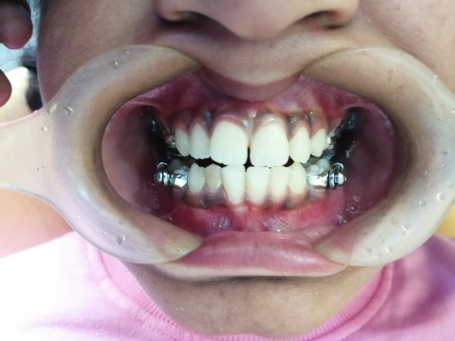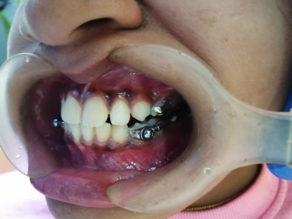
Herbst Appliance: Fixed Jaw Correction for a Better Bite
Correct a retruded lower jaw (Class II overjet) with the Herbst Appliance—a fixed, all-day device that gently guides the lower jaw forward while teeth align. Ideal for growing children and teens who need jaw correction before or alongside braces.
Why Herbst?
- Fixed & continuous: works 24/7 without relying on patient compliance like removable appliances
- Efficient overjet reduction: often achieves results faster than elastic-based methods
- Growth-friendly: encourages natural lower jaw positioning during development
- Often paired with braces for comprehensive alignment
- Can reduce the need for future jaw surgery in moderate cases
Limitations
- Best for growing patients; limited skeletal effect in adults
- Initial speech/chewing adjustment is common
- Requires careful oral hygiene around the appliance
- Not ideal for all bite patterns (e.g., severe open bites or certain dental compensations)
Treatment at a glance
- Consultation + X-rays/scans to confirm Class II and growth status
- Custom Herbst fabricated and bonded to upper/lower teeth (or crowns)
- Active phase: typically 6–12 months of continuous wear
- Follow-up: progress checks every 4–6 weeks
- Next phase: braces or aligners to finalize alignment after jaw correction
Patient instructions & care
- Do not remove the appliance; it's fixed in place
- Brush thoroughly after meals; use interdental brushes or a water flosser around the rods and bands
- Avoid hard/sticky foods (nuts, ice, caramel, hard candies) that can bend or break the device
- Mild discomfort or tongue irritation is normal initially; use orthodontic wax if needed
- If a rod feels loose or the appliance breaks, call us promptly for repair
- Practice speaking and chewing; improvement happens within a few weeks
Expected outcomes
- Reduced overjet and improved bite relationship
- Better jaw positioning and more balanced smile aesthetics
- More stable results when completed during active growth
- Often shortens overall braces time later
Follow-up recommendations
- Regular checks every 4–6 weeks during active correction
- Monitor jaw position and growth with periodic imaging
- Post-correction: transition to braces/aligners for final alignment
- Long-term retention plan to maintain bite and prevent relapse
Book your consultation today and correct your child's overjet with a reliable, fixed solution—the Herbst Appliance.

Retainers
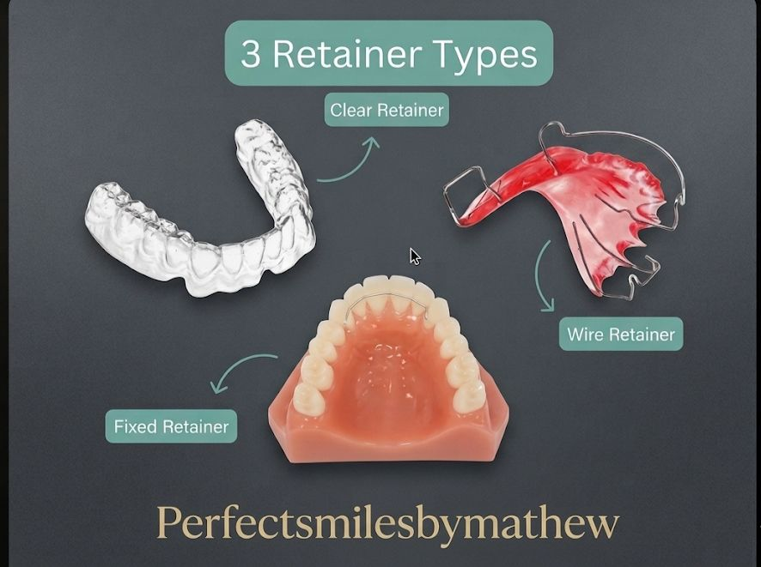
Retainers: Lock In Your New Smile for Life
Protect your orthodontic results with retainers—the essential final step after braces or clear aligners. Without retainers, teeth naturally shift back; with them, your smile stays straight, stable, and confident for years.
Why wear retainers?
- Prevent relapse: keep teeth from shifting post-treatment
- Stable bite: maintain the alignment and jaw relationship you achieved
- Long-term confidence: safeguard your investment in a better smile
- Options for every lifestyle: fixed (bonded) or removable (clear/Hawley)
Types of retainers
- Fixed (bonded): discreet wire behind front teeth; works 24/7 without daily effort
- Removable clear: nearly invisible, easy to clean, ideal for nights
- Hawley (acrylic + wire): durable, adjustable, and great for minor refinement
Limitations
- Must be worn as prescribed; inconsistent use leads to shifting
- Fixed retainers require careful hygiene and can trap plaque if not cleaned well
- Removable retainers can break or warp if exposed to heat or mishandled
- May need replacement over time due to wear or tooth changes
Treatment at a glance
- Post-braces/aligner consult + scan or impression
- Custom retainer fabricated (fixed bonded in-office or removable delivered next visit)
- Wear schedule: often full-time initially (4–6 months), then nightly long-term
- Periodic checks to confirm fit and stability
Patient instructions & care
- Fixed: brush thoroughly + use interdental brushes/water floss; avoid biting hard objects
- Removable clear: wear 20–22 hours/day (or as directed); clean daily with soft brush + cool water or retainer cleaner; never use hot water
- Hawley: clean with a soft brush and mild soap; avoid hot water that can warp acrylic
- Store removable retainers in their case when not worn; never wrap in napkins
- If a retainer feels loose, breaks, or causes pain, call us promptly for an adjustment or replacement
Expected outcomes
- Stable, straight smile with minimal relapse
- Maintained bite function and aesthetics
- Long-term success with consistent wear and follow-up
Follow-up recommendations
- Checkups every 6–12 months to inspect retainer fit and tooth stability
- Replace removable retainers if worn, cracked, or loose
- Continue nightly wear long-term for best stability (many patients wear indefinitely)
- Prompt visit if you notice shifting, tightness, or discomfort
Book your retainer consultation today and lock in your smile—so it stays straight, strong, and confident for life.

TADs (Mini Implants)
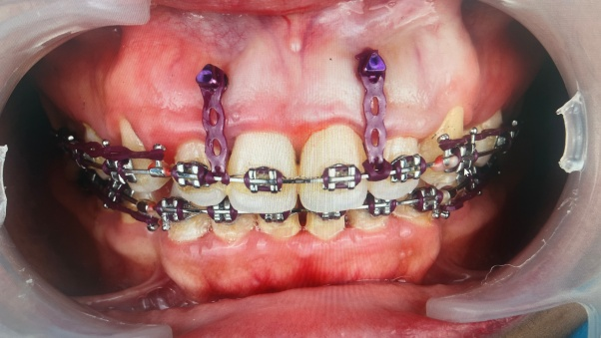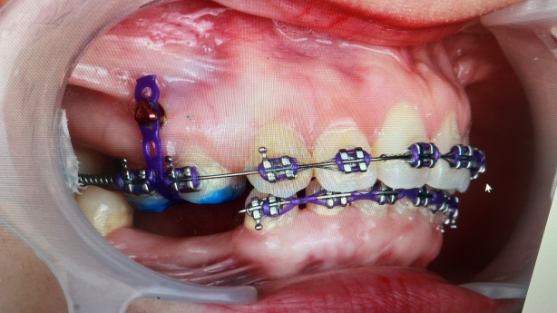
TADs (Mini Implants): Precise Anchorage for Smarter Orthodontics
Power difficult tooth movements with TADs—Temporary Anchorage Devices (mini implants) that act as solid, stationary anchors. They enable precise corrections without relying on patient compliance, often shortening treatment and avoiding extra appliances.
Why choose TADs?
- Precision: move specific teeth exactly where needed
- Compliance-free: works 24/7 without elastics or headgear
- Efficiency: often reduces treatment time and simplifies complex cases
- Less invasive: small, temporary screws placed in bone; removed after treatment
- Versatile: closes gaps, retracts teeth, corrects crossbites, and assists impaction/exposure
Common indications
- Closing large gaps (e.g., after extractions)
- Retracting front teeth without flaring back teeth
- Correcting crossbites or vertical issues
- Assisting with impacted teeth or root uprighting
- Cases where elastics aren't effective or tolerated
Limitations
- Requires minor placement/removal procedure (local anesthesia)
- Not for everyone: limited by bone quality, anatomy, or gum health
- Small risk of minor discomfort, inflammation, or loosening
- May need imaging (CBCT) for safe placement planning
- Not a standalone solution; used with braces or aligners
Treatment at a glance
- Consultation + 3D scan/X-ray to assess bone and plan placement
- Minor procedure: TADs placed under local anesthesia (quick, minimally invasive)
- Active phase: TADs used to anchor wires/elastics for targeted movement (weeks to months)
- Removal: TADs removed easily after treatment; site heals quickly
- Next steps: continue braces/aligners to finalize alignment
Patient instructions & care
- Keep the area clean: brush gently and use interdental brushes or a water flosser around TADs
- Avoid hard/sticky foods that can put excessive force on the device
- Mild soreness after placement is normal; use OTC analgesics if needed
- If a TAD feels loose, causes persistent pain, or irritates gum, call us promptly
- Do not attempt to remove or adjust TADs yourself
Expected outcomes
- More efficient, targeted tooth movement
- Improved control in complex cases
- Often shorter overall treatment compared to elastic-based methods
- Stable results when combined with proper retention
Follow-up recommendations
- Regular checks every 4–6 weeks to monitor TAD stability and movement progress
- Monitor gum health around TADs; prompt care if inflammation occurs
- Removal scheduled once the desired movement is achieved
- Post-TAD: continue braces/aligners and finish with retainers for long-term stability
Book your consultation today and discover how TADs can make your orthodontic treatment faster, more precise, and more predictable.

Elastics
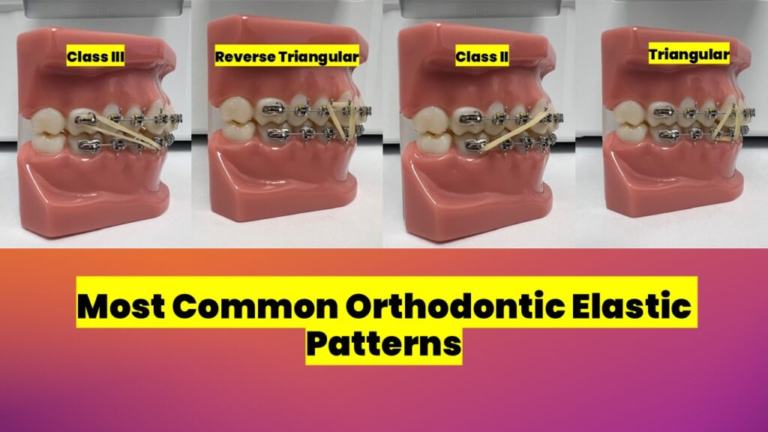
Elastics: Simple, Powerful Bite Correction for Braces Owners
Fine-tune your bite with orthodontic elastics—stretchable bands that connect upper and lower braces to guide jaw relationship and close gaps. A small daily habit that delivers big results for Class II overjets, Class III underjets, and vertical corrections.
Why wear elastics?
- Precise bite correction: moves jaws and teeth into the right position
- Gaps closure: helps close spaces between upper and lower teeth
- Fast results: often works within weeks when worn consistently
- Affordable: low-cost add-on to braces treatment
- Essential for many cases: often required for stable, long-term bite
Common indications
- Class II overjet (retruded lower jaw)
- Class III underjet (protruded lower jaw)
- Vertical issues (open bite or deep bite refinement)
- Midline correction and gap closure alongside braces
Limitations
- Compliance-dependent: must be worn 22+ hours/day for results
- Can break or lose elasticity; needs regular replacement
- May cause temporary soreness or slight speech adjustment
- Not suitable alone: used with braces/aligners, not as a standalone treatment
- Risk of relapse if worn inconsistently
Treatment at a glance
- Prescribed during active braces phase after initial alignment
- You'll receive a supply with clear hook placement instructions
- Wear continuously (22+ hours/day); remove only to eat, brush, and change
- Replace elastics daily (or as directed) to maintain strength
- Progress checked every 4–6 weeks; elastics may be adjusted or discontinued when bite is corrected
Patient instructions & care
- Wear 22+ hours/day: remove only for eating, brushing, and flossing
- Change elastics daily (morning or night) using clean hands
- Stretch gently to hook onto braces; avoid overstretching or snapping
- Keep a spare pack at home, work, and in your bag
- If an elastic breaks, replace it immediately
- Mild soreness is normal; use OTC analgesics if needed
- Store elastics in a cool, dry place; avoid heat that weakens them
Expected outcomes
- Improved bite relationship (Class II/III correction)
- Closed gaps and better midline alignment
- More stable long-term results when worn consistently
- Often shortens overall braces time for bite issues
Follow-up recommendations
- Checkups every 4–6 weeks to monitor bite progress
- Elastics may be reduced or stopped once the bite is corrected
- Continue braces/aligners for final alignment after elastics phase
- Post-treatment: wear retainers as prescribed to maintain bite stability
Top tip: Set a daily reminder to change elastics—consistent wear is the key to success.
Book your consultation today and add elastics to your braces plan for a faster, stronger bite correction.

Oral Hygiene and Braces Care

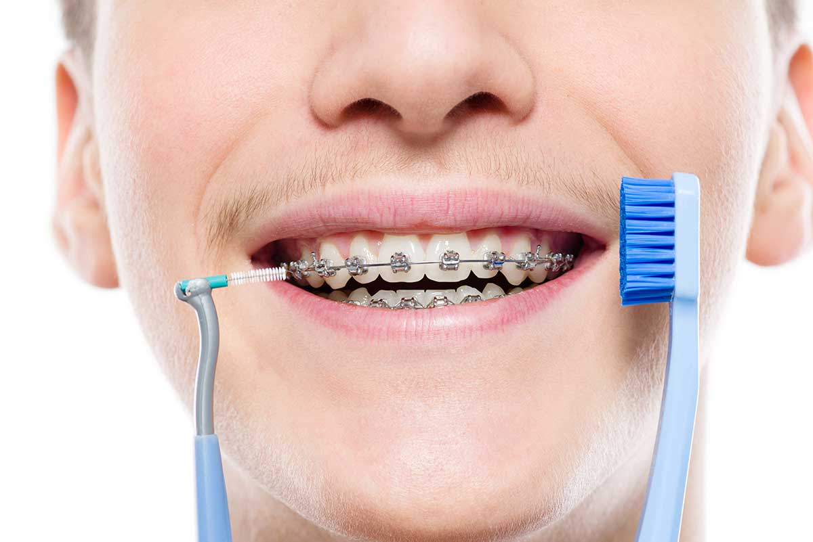
Oral Hygiene & Braces Care: 5 Simple Steps for a Clean, Healthy Smile
Keep your braces clean and your smile strong with this 5-step routine. Do it after every meal to prevent plaque, staining, and gum issues.
Step 1 — Rinse & Prep
Rinse with water to loosen food particles. Grab a soft-bristle brush, fluoride toothpaste, and an interdental aid (interdental brush or floss threader).
Step 2 — Brush Around Brackets
Hold the brush at a 45° angle to the bracket. Gently brush above, below, and around each bracket for 2–3 minutes. Cover all surfaces: front, back, and chewing edges.
Step 3 — Clean Along the Gums
Gently sweep along the gumline in small circles. Be thorough but soft to avoid irritating gums. Fluoride toothpaste helps protect against decay.
Step 4 — Floss Between Teeth
Use a floss threader or interdental brush to clean under the wire and between teeth. Slide gently up and down each side of every tooth.
Step 5 — Rinse & Check
Rinse thoroughly with water or fluoride mouthwash. Use a mirror to check for leftover food. If needed, repeat brushing on any spot that looks dirty.
Quick care tips
- Brush after every meal; don't skip!
- Use interdental brushes or a water flosser for extra cleaning power
- Avoid hard/sticky foods that can trap plaque or break brackets
- Replace your brush every 3–4 weeks or when bristles wear
- Visit your dentist every 3–6 months for professional cleanings

Food Guide
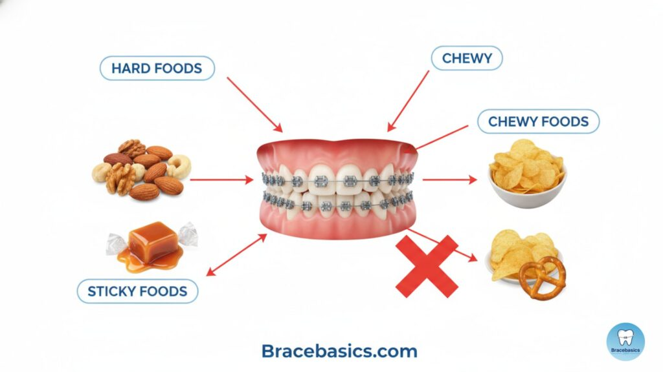
Food Guide During Orthodontic Treatment
For Braces & Clear Aligners (Invisalign)
Smarter eating protects your braces, keeps aligners clear, and speeds up results. Follow this simple guide to stay comfortable, clean, and on track.

✅ Recommended Foods (Safe for Braces & Aligners)
Soft Proteins
- Scrambled eggs, soft-cooked chicken/fish, tofu, lentils, dal, beans
- Paneer, soft cheese, meatloaf
Grains & Carbs
- Rice, pasta, noodles, oatmeal, porridge
- Soft chapati, idli, dosa, well-cooked breads, pancakes, tortillas
Dairy
- Yogurt, curd, milk, pudding, custard, ice cream (without nuts/hard mix-ins)
Soft Fruits (peel or cut small)
- Bananas, berries, melons, papaya, mango, watermelon, kiwi
- Applesauce, cooked apples/pears, smoothies (remove aligners)
Cooked Vegetables (steamed/boiled/mashed)
- Carrots, pumpkin, spinach, broccoli, squash
- Mashed potatoes, boiled vegetables
Snacks & Treats (moderation)
- Soft muffins, cupcakes (no nuts), Jell-O, applesauce cups
Best for First Few Days After Tightening
- Smoothies, soups, oatmeal, mashed potatoes, yogurt, scrambled eggs

❌ Foods to Avoid (Braces & Aligners)
Hard Foods (can break brackets or crack aligners)
- Hard candies, ice, nuts, popcorn kernels
- Raw carrots/apples (unless sliced very thin)
- Seeded breads, crusty bread, hard tortillas
Sticky/Chewy Foods (trap in braces or pull wires)
- Caramel, taffy, gum, licorice
- Bagels, chewy candies, beef jerky
Sugary & Acidic Items (increase decay risk, especially under aligners)
- Candy, chocolates, sodas, energy drinks
- Citrus juices (orange, lemonade)
Staining Drinks (with aligners in)
- Coffee, tea, red wine, cola (remove aligners before drinking)

Aligners-Specific Rules (Invisalign/Clear Aligners)

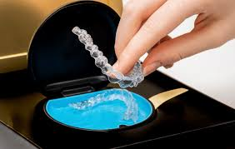
- Remove aligners before eating or drinking anything except plain water
- Never chew food while wearing aligners
- Avoid hot drinks with aligners in (can warp the plastic)
- Brush & floss before reinserting to prevent trapping food/plaque
- Drink only water while aligners are in to avoid staining

Quick Tips for Comfort & Success
- Cut food into small pieces and chew slowly
- Rinse mouth after meals; brush before reinserting aligners
- Keep a soft-food stash for sore days (yogurt, soup, smoothies)
- Replace your toothbrush every 3–4 weeks
- Visit your dentist every 3–6 months for cleanings

Bottom Line: Soft, nutrient-rich foods keep you comfortable and protect your treatment. Avoid hard, sticky, and sugary items to prevent damage and decay. With aligners, remove them before eating and drink only water while wearing.
Stick to this guide and your smile will stay clean, strong, and straight throughout treatment.

Do's & Don'ts Infographic
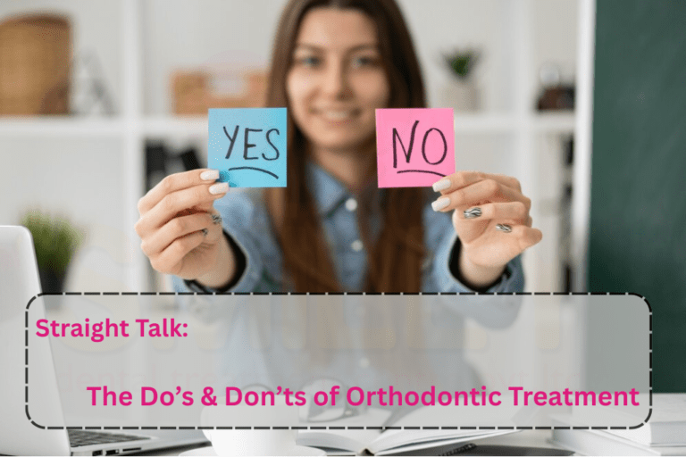
Do's & Don'ts for Orthodontic Success: Your Quick Guide to a Straighter Smile
Make treatment easier, faster, and more comfortable by following these simple rules.
✅ DO
- Wear appliances as directed: braces, aligners, elastics, retainers—stick to your schedule
- Maintain hygiene: brush after every meal, floss daily, and clean your appliances
- Attend appointments: keep every check-up and adjustment on time
❌ DON'T
- Chew ice or bite hard objects: can break brackets or crack aligners
- Bite pens, pencils, or nails: damages your appliances and misaligns teeth
- Miss elastic wear: inconsistent use slows bite correction
- Skip retainer use: teeth shift back without long-term retention
Pro tip: Set reminders for appliance changes and retainer wear—consistency is the key to success.
Follow these do's & don'ts and protect your investment in a confident, healthy smile. Book a check-up if you have questions about your appliance routine.

Emergency Orthodontic Care
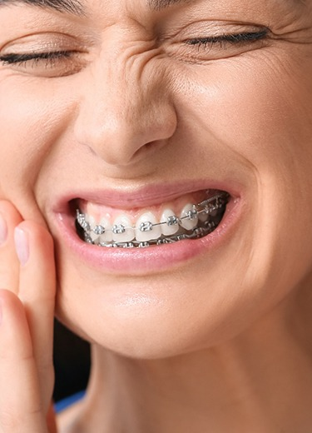
Emergency Orthodontic Care: Quick Fixes for Common Braces & Aligner Issues
Accidents happen—but most orthodontic emergencies are easy to manage at home while you get professional help. Follow this quick guide to stay comfortable and protect your treatment.
🚨 Common Issues & What to Do
Loose Bracket
- Leave it in place if still attached; if it's loose, remove and save it
- Cover any sharp edges with orthodontic wax
- Call us to schedule a repair visit
Poking Wire
- Use a clean pencil eraser to gently push the wire back toward the bracket
- If it won't move, cover the sharp end with orthodontic wax
- Don't try to cut the wire yourself unless instructed
Lost Separator
- It's usually not urgent unless space is closing
- Keep your appointment if scheduled; call us if you notice teeth shifting
Broken Appliance (aligner, expander, retainer)
- Stop using the broken piece immediately
- Bring it to your appointment for assessment
- For broken aligners, switch to your previous or next tray only if advised
Discomfort or Soreness
- Rinse with warm salt water (1 tsp salt in 8 oz warm water) 2–3 times/day
- Use OTC analgesics (ibuprofen or acetaminophen) as needed
- Soft foods + avoid hard/sticky items until soreness fades
🛡️ At-Home Emergency Kit
- Orthodontic wax
- Warm salt water for rinsing
- OTC pain relievers
- Clean pencil eraser (for pushing wires)
- Small container for loose parts
📞 When to Call Us
- Bracket or wire causes persistent pain or cuts your mouth
- Appliance is broken and won't stay in place
- You notice teeth shifting quickly after a break
- Any issue that doesn't improve within 24–48 hours with home care
Don't wait—contact your orthodontist promptly for repairs. Most emergencies are fixed in one visit, and quick action keeps your treatment on track.
Book an emergency appointment today and get back to a comfortable, confident smile.

Frequently Asked Questions
Frequently Asked Questions: Quick Answers About Your Orthodontic Treatment
How long does treatment take?
Most cases take 12–36 months, depending on complexity. Your orthodontist will give you a personalized timeline after your evaluation.
Do braces hurt?
Mild soreness for a few days after bonding or adjustments is normal. Over-the-counter pain relievers and warm salt rinses help.
Can I play sports?
Yes! Wear a mouthguard for contact sports. Non-contact athletes can usually play without one.
How often are visits needed?
Typically every 4–8 weeks for braces; aligner patients may check in every 8–12 weeks (sometimes remotely).
What if a bracket breaks?
Use orthodontic wax for comfort and call us promptly. Most repairs are quick and done in one visit.
How long should retainers be worn?
Long-term—often nightly for years. Many patients wear retainers indefinitely to prevent teeth from shifting back.
Need more details? Book your consultation and get personalized answers tailored to your case.

